The W WINTER BREAK INTROSPECTIVE EXERCISE:
The Temple Challenge
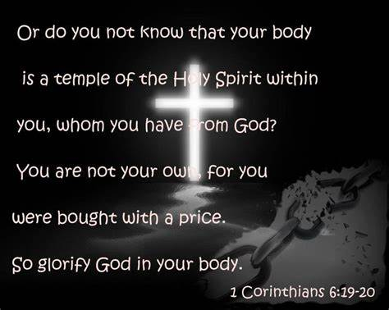

We have had the privilege of studying the Word of God throughout 2023. Over the break, I would like to challenge each of you to take an introspective look at yourself as the temple of God and consider the condition of your edifice as the abode of the Holy Spirit. Consider cracks you may have in your foundation, holes you may have in your walls, or mold and mildew that may be harmful to your spirit man.

Take some time and research scriptures that address the problem area(s) and make a commitment to make those repairs. How will you allow the word of God to change your behavior as, God willing, we move into 2024? Below are some possible scriptures to get you thinking, but please research other scriptures that may be more appropriate for your temple.

Romans 12:1-2 Psalms 27:10 Proverbs 3:1-2 Col 3:12-15
1Peter 3:9 1Samuel 16:7 Psalms 139:13-17 1John 3:24
Jeremiah 15:16 Heb 4:12,13 Rom 15:4 Psalms 90:12
1Peter 5:7 Psalms 92:12-14 Pro 31:30 1Pet 3:3-4
Rom 5:3-4 Phil 2:13 Deu 11:18-21 1Tim 4:12,13
Psalms 119:11 2Cor 1:3-4 John 16:33 Eph 2:10
2Peter 1:3 Isa 43:2 Eze 36:26 Rom 7:5-6
Deu 8:5 Heb 12:10-11 1Peter 1:7 Isaiah 40:29-31
Mark 8:34-35 Gal 5:16-26 Psalms 32:5 Psalms 51:17
Matthew 6:34 2Cor 9:7-8 Psalms 15:1-5 1Cor 10:13

Record your thoughts and I am praying for a mighty move of God over your life. May the bold in Christ come prepared Wednesday, January 17, 2024, prepared to testify how the Lord has changed your perspective of who you are in Him.

